Project Design Phase-II
Technology Stack (Architecture & Stack)

Date | 29 september 2026
Team ID | 6ab3db0c6603573ccfb381c9
Project Name | AI WeatherWise
Maximum Marks | 4 Marks

Technical Architecture:
AI WeatherWise uses a web-based architecture with HTML, CSS, JavaScript, PHP, MySQL, and Weather API to collect and display weather data.
The system processes weather data using AI techniques and provides forecasts, weather insights, and alerts through a user-friendly interface.
Example: Order processing during pandemics for offline 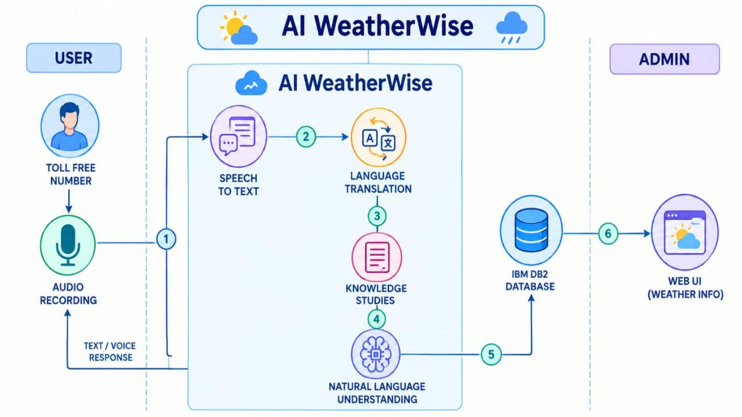
Table-1 : Components & Technologies:
S.No | Component | Description | Technology
 | User Interface | How user interacts with application e.g.  Web UI, Mobile App, Chatbot etc. | HTML, CSS, JavaScript
 | Application Logic-1 | Logic for a process in the application | php
 | Application Logic-2 | Logic for a process in the application | PHP, JavaScript
 | Application Logic-3 | Logic for a process in the application | Python / AI Techniques
 | Database | Data Type, Configurations etc. | MySQL
 | Cloud Database | Database Service on Cloud | MySQL / XAMPP
 | File Storage | File storage requirements | Local File System
 | External API-1 | Purpose of External API used in the application | Weather API
 | External API-2 | Purpose of External API used in the application | Geolocation API
 | Machine Learning Model | Purpose of Machine Learning Model | AI / Machine Learning
 | Infrastructure (Server / Cloud) | Application Deployment on Local System / Cloud  Local Server Configuration:  Cloud Server Configuration : | XAMPP, Apache Local Server

Table-2: Application Characteristics:
S.No | Characteristics | Description | Technology
 | Open-Source Frameworks | List the open-source frameworks used | HTML, CSS, JavaScript, PHP
 | Security Implementations | List all the security / access controls implemented, use of firewalls etc. | PHP Session, Password Hashing, Input Validation
 | Scalable Architecture | Justify the scalability of architecture (3 – tier, Micro-services) | PHP, MySQL, Weather API
 | Availability | Justify the availability of application (e.g. use of load balancers, distributed servers etc.) | Apache, XAMPP, Web Browser
 | Performance | Design consideration for the performance of the application (number of requests per sec, use of Cache, use of CDN’s) etc. | PHP, JavaScript, API

